Parental Behavior Agreement

I ________________________________________________________(your name),

the parent of ______________________________________________(your child),

agree to the following code of behavior before, during, and after games or practices.

(Initial Below)

_______ I will not yell at, ridicule, threaten, harm, or express disagreement with referees, players, coaches, staff, administrators or other parents.

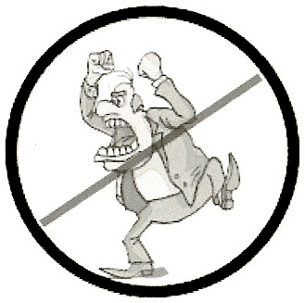
_______ I will not use profanity.

_______ I will not drink alcoholic beverages, use tobacco products, or use illegal drugs.

_______ I will not go on the playing field unless summoned by the referee. I will remain in the designated spectator area.

_______ I will not coach or give direction to the players, including my own children.

_______ I will keep all my comments and actions positive.

_______ I will encourage my child to play fairly and with good sportsmanship, even if I do not think the other team, coaches, or referees are doing so.

I understand that if I break this agreement, I may be temporarily suspended from attending games for some, or all of the season, and my child may be removed from the team and not allowed to play. If I am suspended, I understand that I will not be entitled to a refund of any registration fees or other expenses.

Signed ______________________________________ Date __________________

